# Lab: Enumerations and Annotations

Problems for exercises and homework for the ["Java OOP Advanced" course @ SoftUni](https://softuni.bg/courses/java-oop-advanced).

You can check your solutions here: <https://judge.softuni.bg/Contests/524/Enumerations-and-Annotations-Lab> .

# Part I: Enumerations

## Weekdays

Create Enum Weekday with the days from **Monday** through **Sunday**. Override toString(), which should return weekdays with a capital first letter, in format **"Monday"**, **"Tuesday"**, etc.

Create a class WeeklyCalendar that should have at least the methods:

* void addEntry(String weekday, String notes)
* Iterable<WeeklyCalendarEntry> getWeeklySchedule() - returns weekly entries sorted by day in ascending order

Create a class WeeklyEntrywhich should have constructor:

* WeeklyEntry(String weekday, String notes)

OverridetoString()ofWeeklyEntry – "{**weekday**} - {**notes**}" (e.g. "Monday - sport", "Sunday - sleep")

### Examples

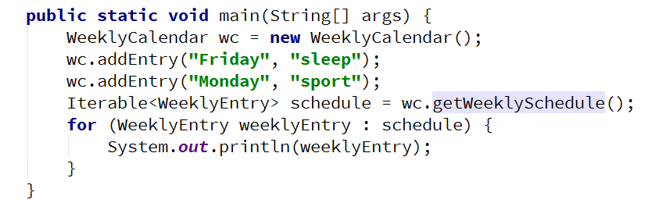

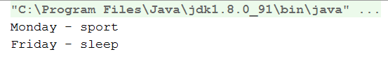

### Hints

Create enum Weekday and override its toString() method:

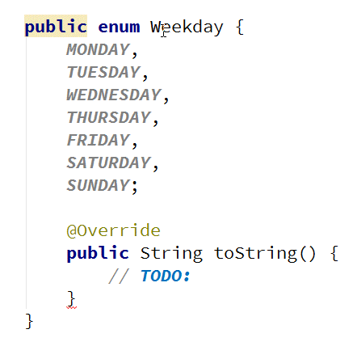

Create WeeklyEntry and think about a solution to compare entries:

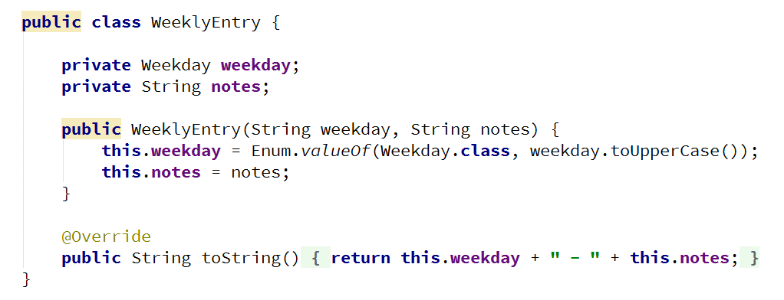

Create the WeeklyCalendar:

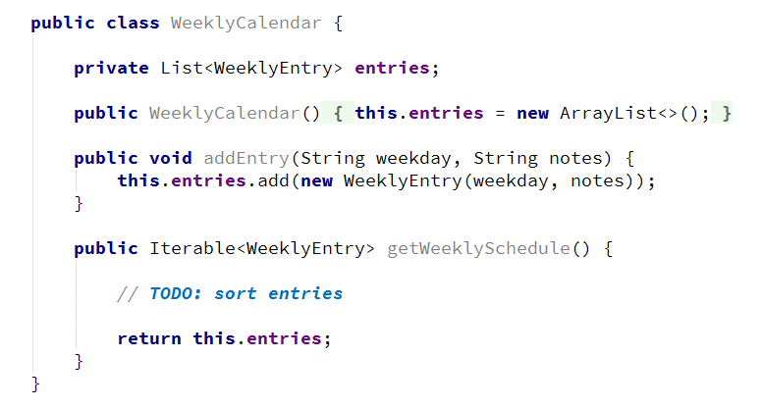

## Warning Levels

Create a classes Logger and Message.

Create enum Importance with constants - Low, Normal, Medium, High.

The Logger should have a method that **receives a message**, but **records** only messages **above or equal to a given importance** level.

Create a method

* Iterable<Message> getMessages()

### Examples

|  |  |
| --- | --- |
| **Input** | **Output** |
| HIGH  NORMAL: All systems running  HIGH: Leakage in core room  LOW: Food delivery  END | HIGH: Leakage in core room |
| LOW  NORMAL: All systems running  HIGH: Leakage in core room  LOW: Food delivery  END | NORMAL: All systems running  HIGH: Leakage in core room  LOW: Food delivery |

## Coffee Machine

Create a class CoffeeMachine, with methods:

* void buyCoffee(String size, String type)
* void insertCoin(String coin)
* Iterable<Coffee> coffeesSold()

Create enum CoffeeType – Espresso, Latte, Irish

Create enum Coin – 1, 2, 5, 10, 20, 50 (constants should be named ONE, TWO, FIVE, etc.)

Create enum CoffeeSize that has **dosage** and **price** – Small (50 ml, 50 c), Normal (100 ml, 75 c), Double (200 ml, 100 c)

CoffeeMachine should **clear all coins after each successful coffee sold**.

### Examples

|  |  |
| --- | --- |
| **Input** | **Output** |
| TEN  TWENTY  TWENTY  Small Espresso  END | *(no output) Machine should have only one "Small Espresso" sold* |
| TEN  TWENTY  Small Espresso  TWENTY  Small Espresso  END | *(no output) Machine should have only one "Small Espresso" sold*  *Comment: first try - not enough coins* |

# Part II: Annotations

## Create Annotation

Create annotation Subject with a String[] element called **categories**, that**:**

* Should be available at runtime
* Can be placed only on types

### Examples

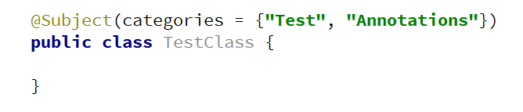

## Coding Tracker

Create annotation Author with a String element called **name**, that:

* Should be available at runtime
* Can be placed only on methods

Create a class **Tracker** with a method:

* static void printMethodsByAuthor()

### Examples

